**Report: Hospital Admission Trends**

This report analyzes hospital admission trends using time-series data. The analysis includes formatting date columns, grouping data by different time intervals, and visualizing admission trends to identify seasonal patterns and peak periods.

**Data Preparation**

The dataset was loaded, and the date columns were formatted using pd.to_datetime() to ensure accurate time-series analysis. This step is crucial for grouping the data by day, week, and month.

**Grouping Data**

The admission data was grouped by day, week, and month to observe trends over different time intervals. This grouping helps in understanding the frequency and distribution of hospital admissions.

**Visualization**

Line plots were generated to visualize hospital admissions over time. These visualizations provide a clear picture of how admissions fluctuate daily, weekly, and monthly.

**Daily Admissions**

The daily admissions line plot shows the number of admissions each day. This plot helps in identifying any daily patterns or anomalies in hospital admissions.

**! Daily Admissions**

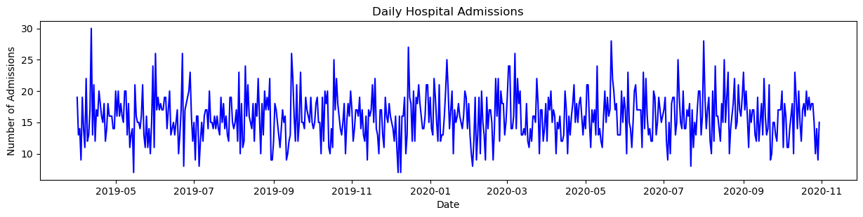

***Figure 1: Daily Hospital Admissions***

**! Weekly Admissions**

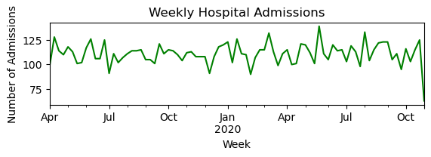

***Figure 2: Weekly Hospital Admissions***

**Monthly Admissions**

**The monthly admissions line plot further aggregates the data into monthly intervals, providing a high-level view of admission trends over longer periods.**

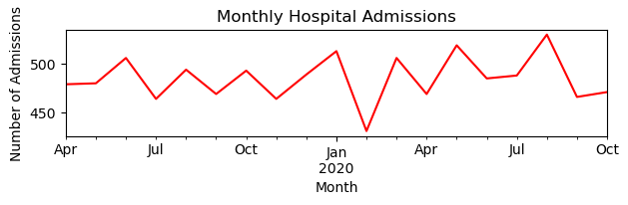

***Figure 3: Monthly Hospital Admissions***

**Analysis of Seasonal Patterns and Peak Periods**

The analysis identified peak admission periods:

Peak Daily Admission: April 12, 2019, with 30 admissions.

Peak Weekly Admission: Week of May 18-24, 2020, with 139 admissions.

Peak Monthly Admission: August 2020, with 530 admissions.

These peaks indicate times of higher demand for hospital services, which could be due to various factors such as seasonal illnesses or specific events**.**

**In The End**

**The time-series analysis of hospital admissions reveals significant trends and peak periods. These insights can help hospital management optimize resource allocation and improve patient care during high-demand periods. Understanding these patterns is essential for planning and ensuring that the hospital can meet patient needs effectively.**